Serverless Assignment

Assignment 1: Automated Instance Management Using AWS Lambda and Boto3
1.Tagging: Auto – Stop, Instance ID-1: i-0e3ceaac5584d647a Initial Status: - Running
2.Tagging: Auto - Start, Instance ID-2: i-0f838e6e656992dcf Initial Status: - Stopped

Screenshots:
- EC2 Setup Verification
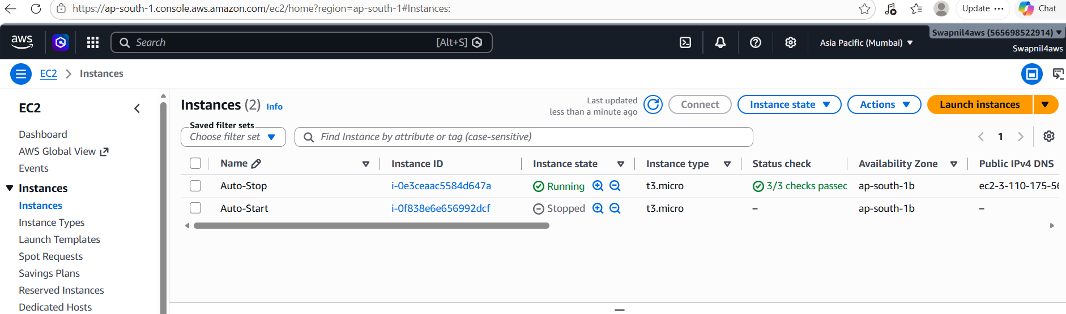

- IAM Role Setup Verification
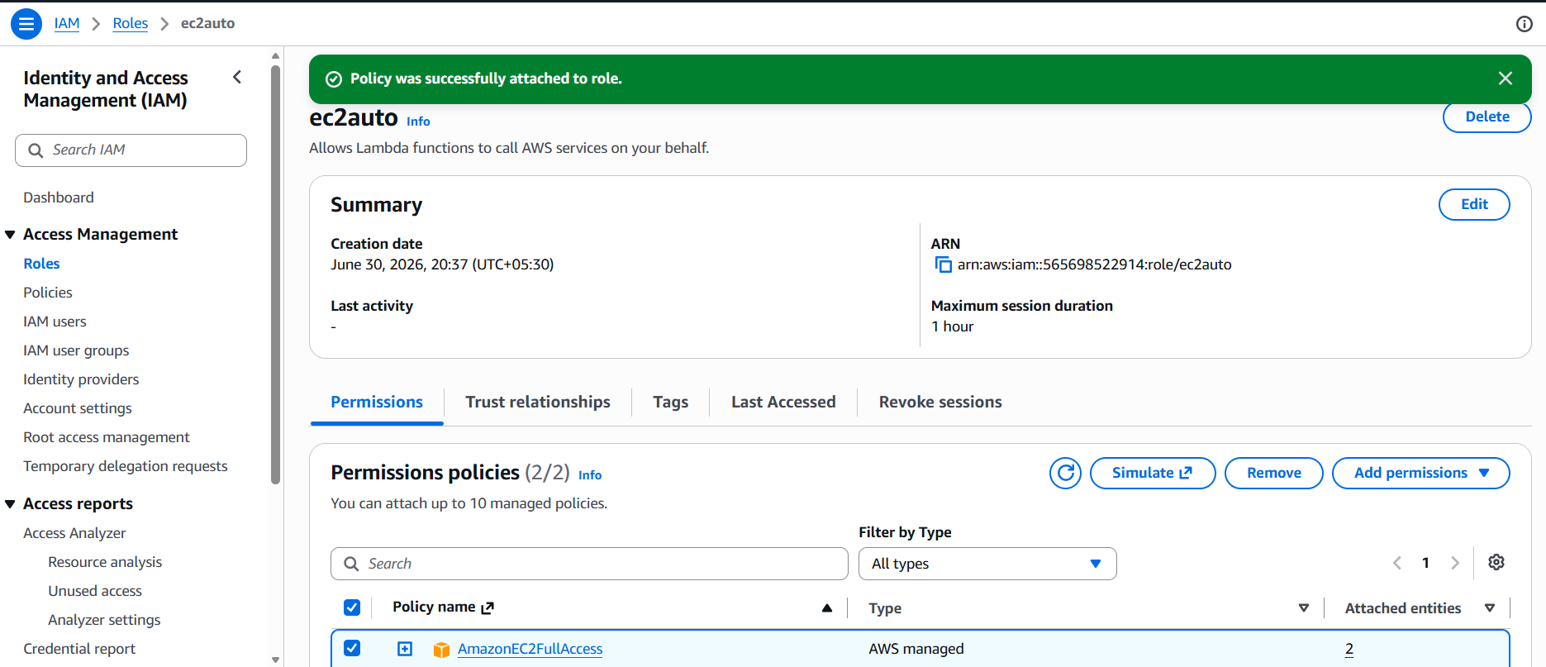

- Lambda Function Configuration
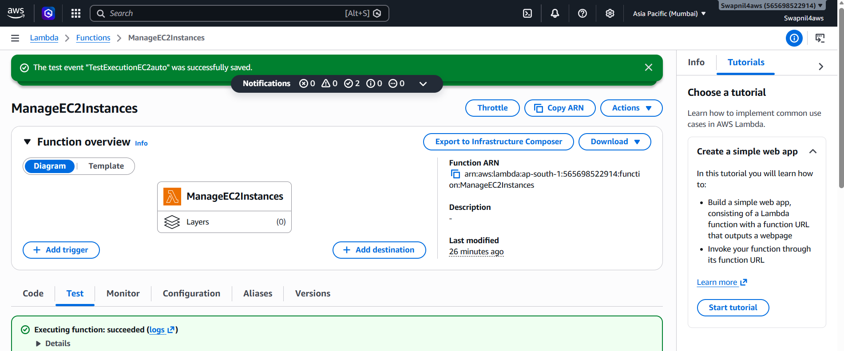

- Lambda Test Success
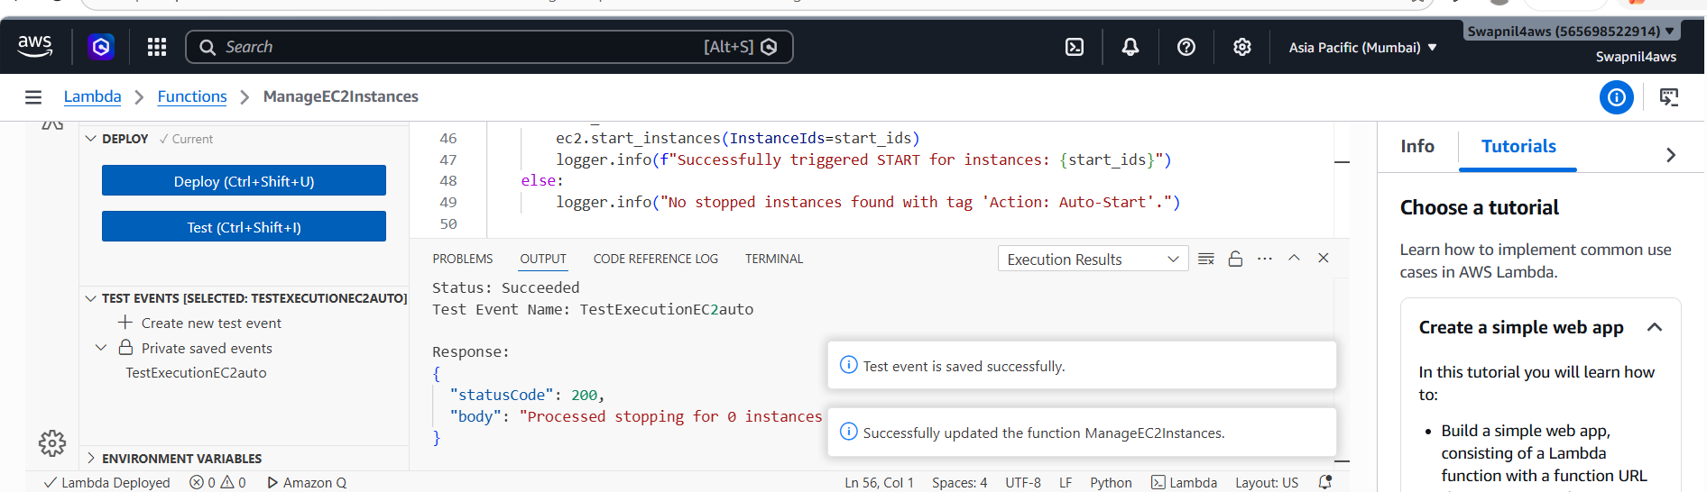

- EC2 Status Post Lambda function successfully tested.
(i.e. Checked EC2 dashboard and confirmed that the instances' states have changed according to their tags).
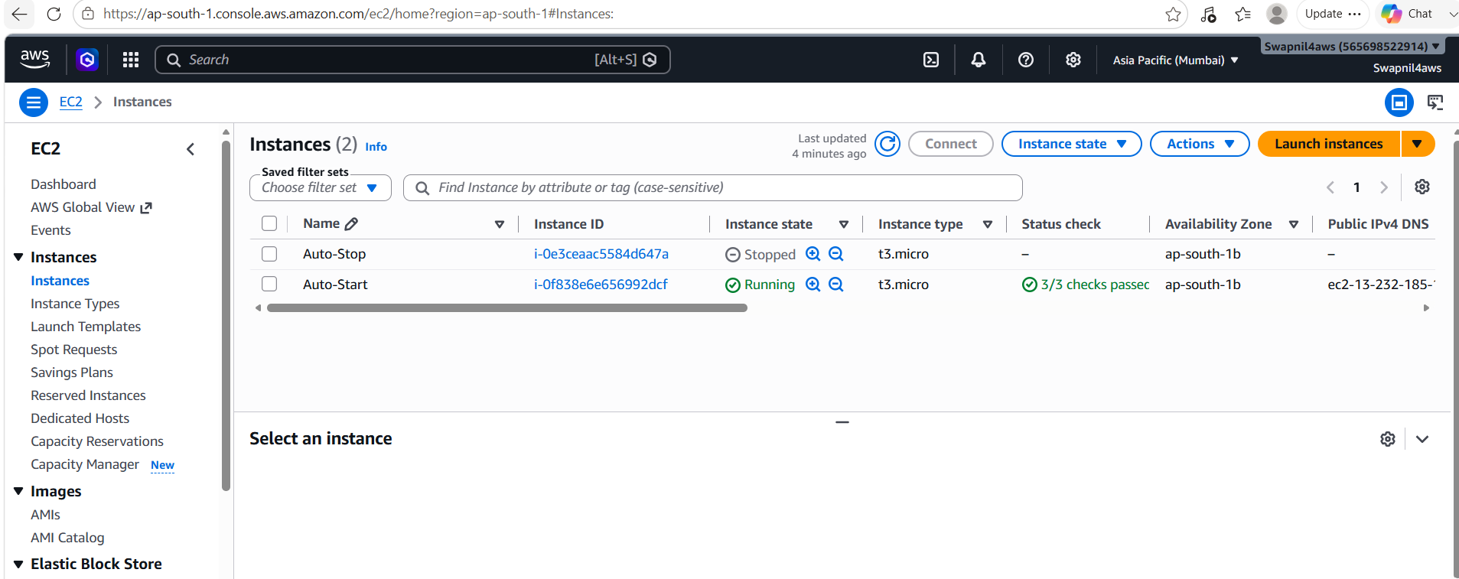
Assignment 2: Automated S3 Bucket Cleanup
Automated serverless script running on AWS Lambda using Boto3 to sweep an S3 bucket and permanently delete object files using a custom retention lifecycle policy.

Step 1: S3 Bucket Setup
Bucket Name: my-cleanup-target-bucket-2026
Object Seeding: Uploaded multiple tracking testing files with visible timestamps.
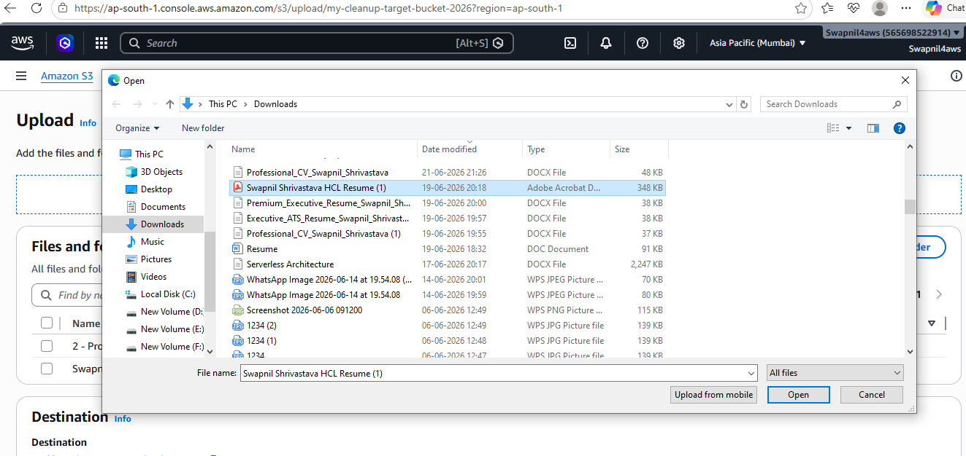
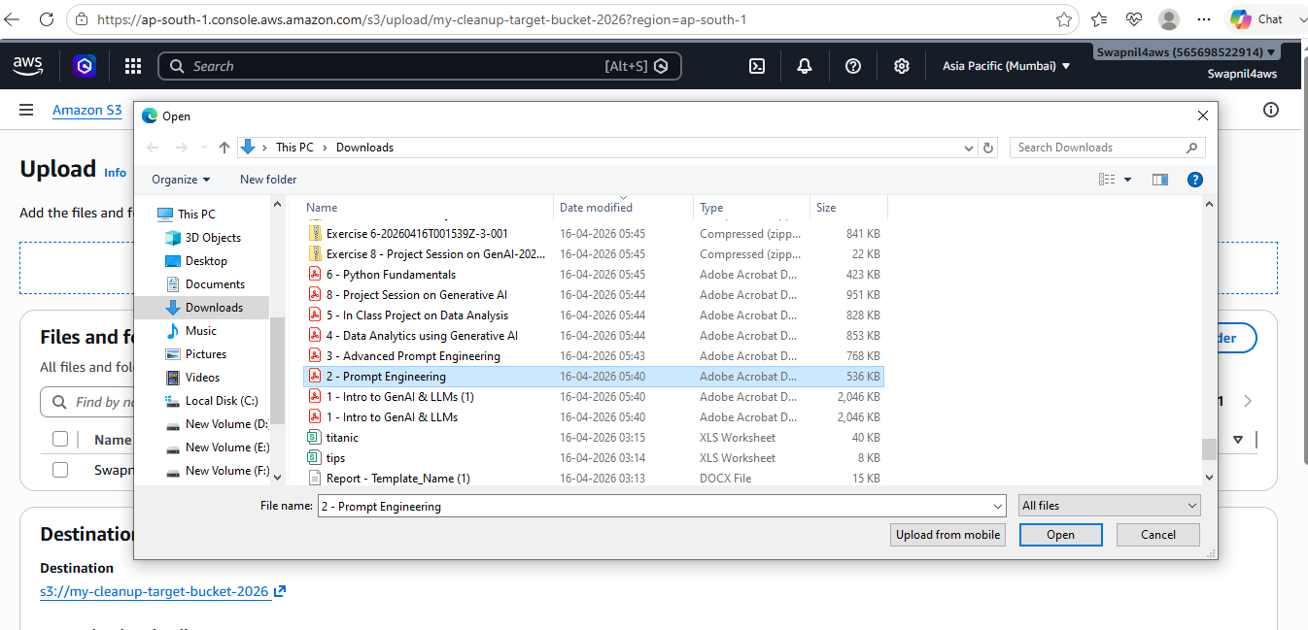
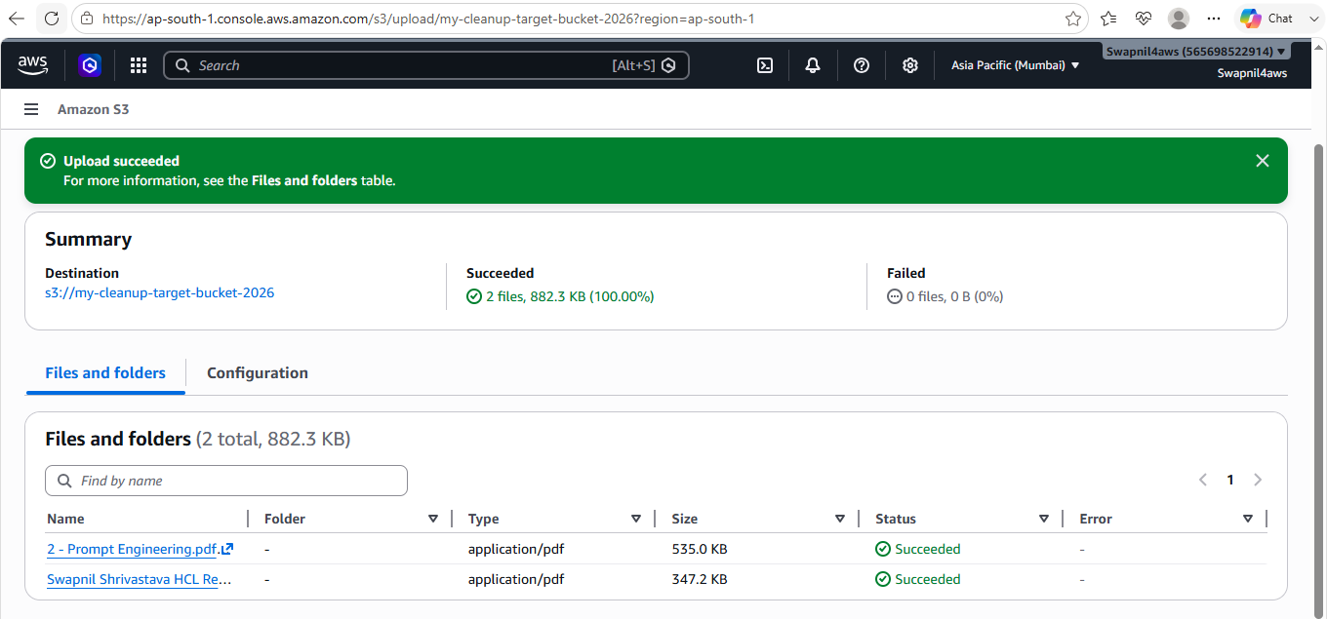

Step 2: Lambda IAM Role Set Up Configuration

Permissions Policy: LambdaS3CleanupPolicy

Role Name: LambdaS3CleanupRole

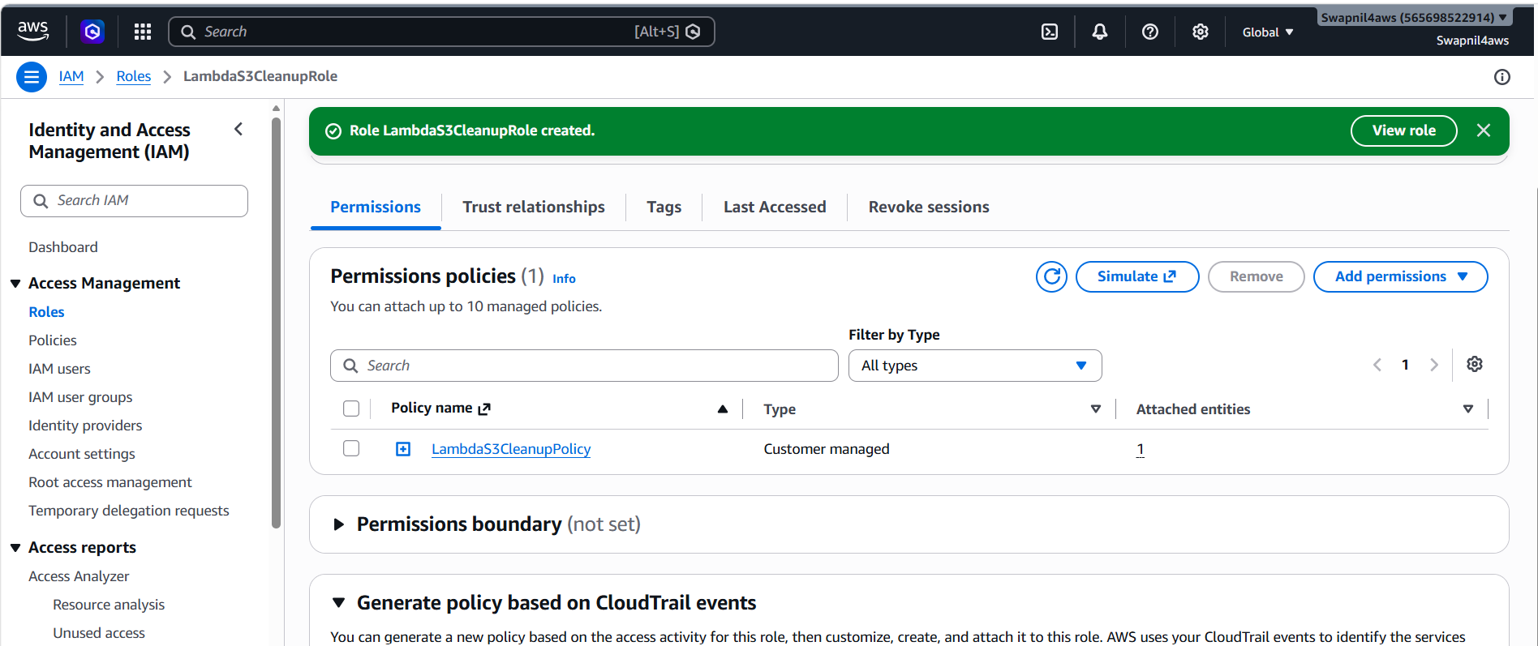

Step 3: Create the AWS Lambda Function
Function Name-S3BucketCleanup
Runtime Workspace- Python 3.12
Execution Role-LambdaS3CleanupRole

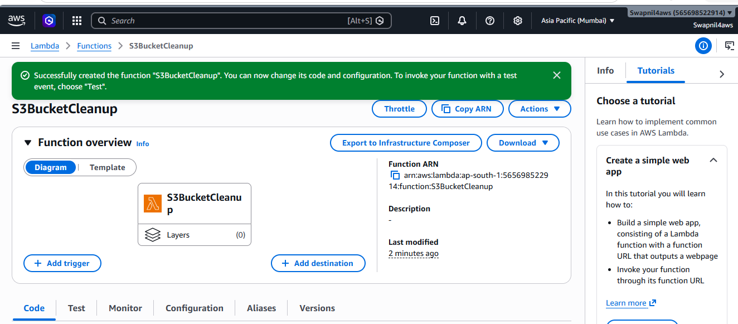

Step 4: Write and Deploy the Code
Lambda Code deployment
Source code is located inside lambda_function.py
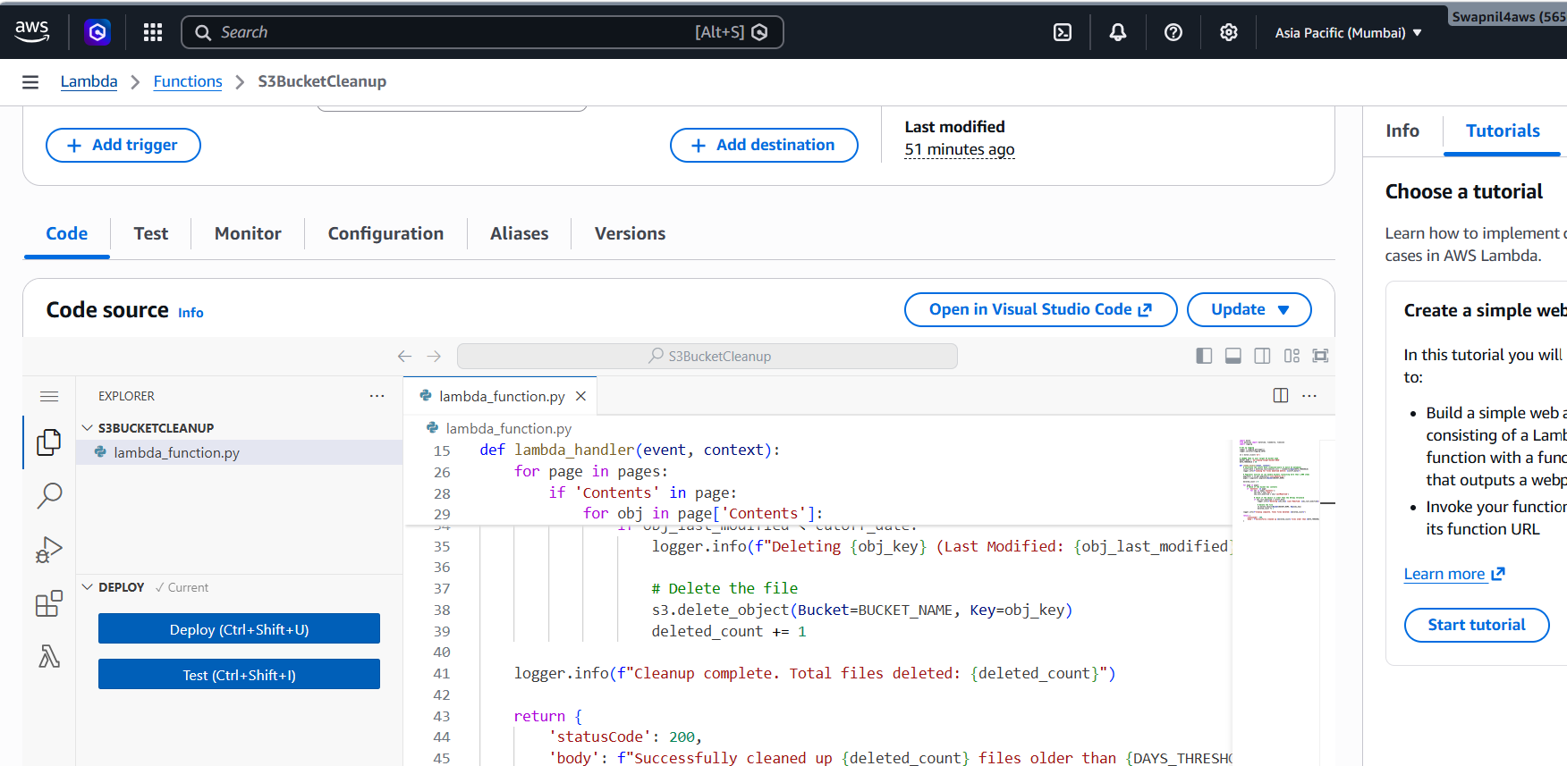
Step 5: Manual Invocation & Verification
The function was manually triggered using an ‘TestCleanup’ mock event profile. The runtime cleared out all old testing elements successfully.
